THE CHARITIES ACT (NORTHERN IRELAND) 2008
THE CHARITIES ACT (NORTHERN IRELAND) 2013
THE CHARITY TRIBUNAL RULES (NORTHERN IRELAND) 2010

The Charity Tribunal for Northern Ireland

Application Reference: 3/18

Sitting in Chambers

Before

Damien J. McMahon
President

Between

KYLE HEFFERNAN
Appellant
-and-

THE CHARITY COMMISSION FOR NORTHERN IRELAND
Respondent

Decision

UPON READING correspondence dated 21 April 2020 Respondent’s Legal Adviser confirming that the Respondent was withdrawing its opposition to this appeal in its entirety;

And there being no objection from the appellant or his representative;

IT IS ORDERED THAT:

- This appeal is formally allowed pursuant to Rule 24(2) of the Charity Tribunal Rules (Northern Ireland) 2010.

- Pursuant to section 13(6) and (7) of the Charities Act (Northern Ireland) 2008, the Tribunal makes no order as to costs.

Signed

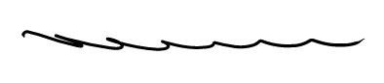

Damien J. McMahon]
President

Date: 21 August 2020

