THE CHARITIES ACT (NORTHERN IRELAND) 2008
THE CHARITIES ACT (NORTHERN IRELAND) 2013
THE CHARITY TRIBUNAL RULES (NORTHERN IRELAND) 2010

The Charity Tribunal for Northern Ireland

Appeal Reference: 10/19

Sitting in Chambers

Before

Damien J. McMahon
President

Between

GREGORY BURKE
Appellant
-and-

THE CHARITY COMMISSION FOR NORTHERN IRELAND
Respondent

Decision

UPON READING correspondence dated 15 July 2020 from the Appellant confirming that he wished to withdraw his appeals;

And UPON READING correspondence dated 20 July 2020 from the Legal Adviser for the Respondent confirming that the Respondent had no objection;

IT IS ORDERED THAT:

- This appeal is formally dismissed pursuant to Rule 24(1) of the Charity Tribunal Rules (Northern Ireland) 2010.

- No order as to costs.

Signed

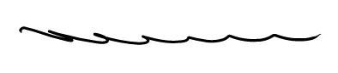

Damien J. McMahon
President

Date: 21 August 2020

