THE CHARITIES ACT (NORTHERN IRELAND) 2008
THE CHARITIES ACT (NORTHERN IRELAND) 2013
THE CHARITY TRIBUNAL RULES (NORTHERN IRELAND) 2010

The Charity Tribunal for Northern Ireland

Appeal Reference: 3/24

Sitting in Chambers

Before

Damien J. McMahon
President

Between

CATHOLIC MOTHERS IRELAND LIMITED
Appellant
-and-

THE CHARITY COMMISSION FOR NORTHERN IRELAND
Respondent

Decision

WHEREAS the Appellant, on 16 September 2024, lodged a Notice of Appeal against a decision of the Respondent dated 22 August 2024 refusing the Appellant entry onto the Register of Charities;

AND UPON READING correspondence dated 24 October 2024 from the Appellant confirming that the Appellant wished to withdraw this appeal;

And UPON there being no objection from the Respondent;

IT IS ORDERED THAT:

- This appeal is hereby formally dismissed pursuant to Rule 24(2) of the Charity Tribunal Rules (Northern Ireland) 2010.

- Pursuant to section 13(6) and (7) of the Charities Act (Northern Ireland) 2008, the Tribunal makes no order as to costs.

Signed

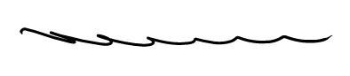

Damien J. McMahon
President,
Charity Tribunal for Northern Ireland

29 October 2024

